Weaverham & Acton Bridge Village Show 2023

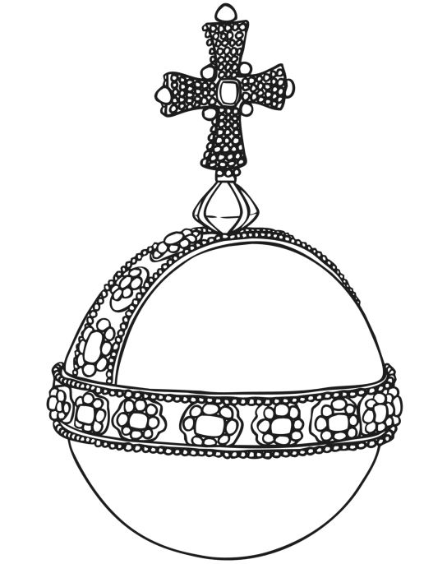
K2 – Colour an Orb

